10-01-2019

MECE 101 Final

Name: Surname: Number: Signature:

Q1) A function is given below:

function[output1,output2,output3]=sinav_function(a,b,k,n)

for i=1:n,

a=k*(a+b);

k=b;

b=a;

end

output1=a;

output2=b;

output3=k;

end

We call this function as:

**[output1,output2,output3]=sinav_function(1,1,1,4)**

What is ‘output1’, ‘output2’ and ‘output3’? **(25 points).**

Q2) A function is given below:

function [count_perfect,count]=division_rule(n,k)

count_perfect=0;

count=0;

number=n;

while number>1,

division1=number/k;

division2=floor(number/k);

if division1==division2,

number=division1;

count_perfect=count_perfect+1;

else

number=division2;

count=count+1;

end

end

end

1. We call this function as below. What is ‘count_perfect’ and ‘count’? **(25 points)**

**[count_perfect,count]=division_rule(81,3)**

1. We call this function as below. What is ‘count_perfect’ and ‘count’? **(25 points)**

**[count_perfect,count]=division_rule(22,2)**

**Hint: ‘floor’ function in MATLAB rounds the input towards negative infinity**

**Ex: floor(5.0001) $→$ 5, floor(5) $→$ 5, floor(5.999999) $→$ 5, floor(4.999) $→$ 4, floor(0.0001)0**

3) For the Simulink model below the inputs are a(t)=5Sin(2πf1t) where f1=0.25 Hertz, b(t)=2. There is a summation component and absolute value taking component as in the figure.

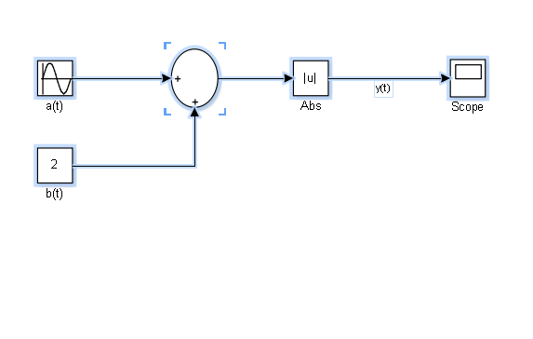

1. What is y(t)? **(10 points)**
2. Draw y(t) (for drawing use the figure with grids below). **(15 points)**

